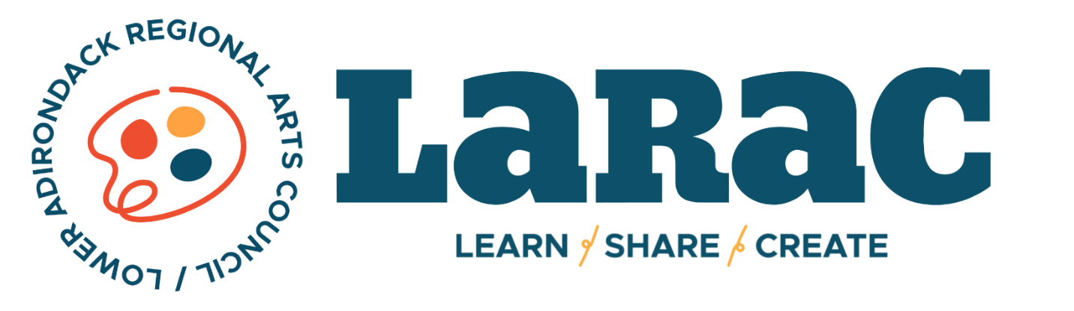

NON-PROFIT APPLICATION
ANNUAL LARAC ARTS FESTIVALS
June 8 - 9th 2024

INFORMATION TABLE PRICE: $100
Must supply your own table.

10X10 BOOTH PRICE: $175
Must supply your own tent.
Describe your set-up and any activities you are planning as well as cost to consumer.
Any items you intend to sell must be handmade and approved by the LARAC Festival Jury.

Organization: ______________________________________________________________________________________

Contact Name: _____________________________________________________________________________________

Email Address: ____________________________________________________________________________________

Phone Number: ___________________________________________________________________________________

We agree our organization will provide staff and materials to run our activity on both days during the LARAC Arts Festival. We also agree to submit application and payment by May 3, 2023

Signature ________________________________________ Date ________________________

